**1. How can AWS be used for data analytics, and what are the advantages of using AWS in this context?**

Ø **What is Data Analytics?**

* Data analytics converts raw data into actionable insights.
* It includes a range of tools, technologies, and processes used to find trends and solve problems by using data.
* Data analytics can shape business processes, improve decision-making, and foster business growth.

Ø **Workflow for doing Data Analysis**

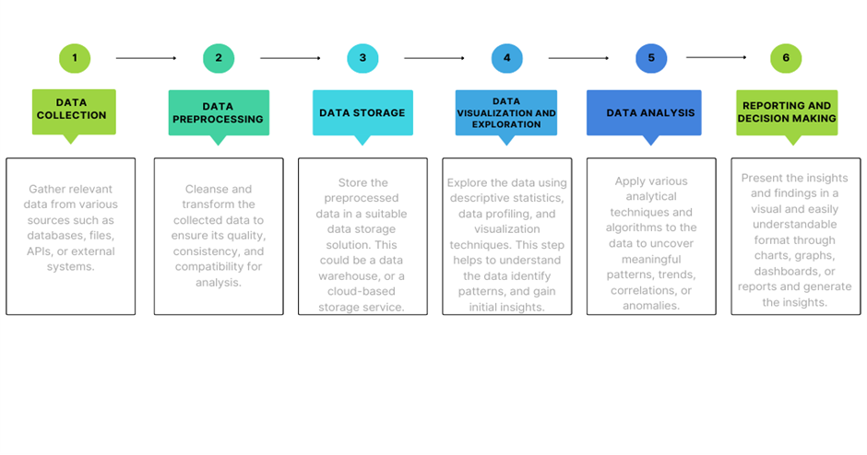

Ø **Where is data Analytics used for?**

* To reduce overall business costs
* Develop new and innovative products and services
* To predict Future sales or purchasing behaviors
* To help and Protect Against fraud
* To analyze the effectiveness of marketing campaigns
* To boost customer acquisition and retention
* To increase supply chain efficiently.

Ø **How can AWS be used for data analytics?**

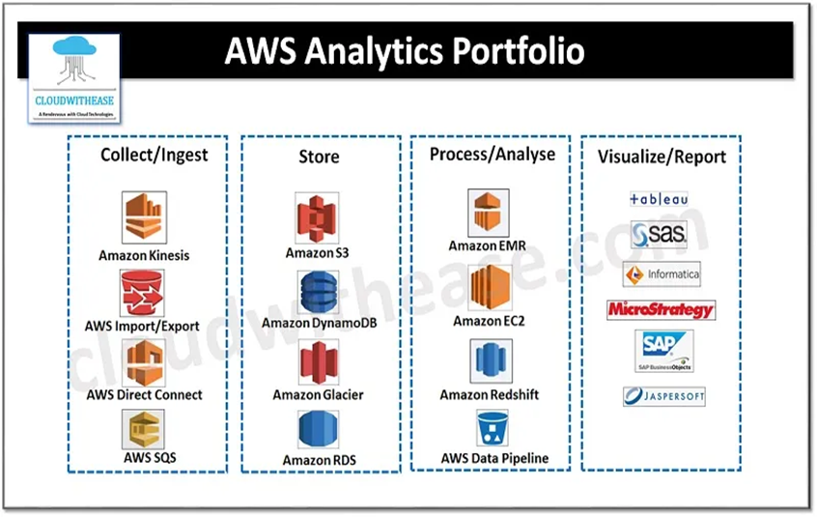

**Data collection / Ingestion :**

* **Amazon Kinesis** – Amazon Kinesis is a feature of Amazon Web Services (AWS) that easily gathers or collects, processes, and analyses video and data streams in a real-time environment. It has four components namely – Video Stream, data stream, data fire hose and data analytics. Amazon Kinesis Data Analytics is a new ML introduced to detect “hotspots” in the streaming data. A real time processing engine to write and execute SQL queries to have meaningful information from the data and you only pay for processing of resources that your streaming application is using.
* **AWS Import/Export** – AWS Import/Export service accelerates transfer of large amounts of data into and out of AWS using physical storage appliances, bypassing the Internet. Data is copied to a device (At source) and shipped via standard shipping mechanisms, and finally copied to (Destination).
* **AWS direct connect** – AWS Direct Connect links internal networks to an AWS direct Connect location over a standard Ethernet fibre-optic cable to achieve highly resilient network connections between Amazon Virtual Private Cloud (Amazon VPC) and their on-premises infrastructure.
* **AWS SQS** – Amazon SQS is a web service which gives access to message queues that store messages waiting to be processed making applications more flexible and reliable.

**Data Storage:**

* **Amazon S3** – easy to use and cheap storage service and can be used by S3 to store any amount of data for a wide range of use cases such as web hosting, data archival , software delivery and so on.
* **Amazon DynamoDB** – DynamoDB is a hosted NoSQL database offered by Amazon Web Services (AWS), reliable performance with scalability and managed experience.
* **Amazon Glacier** – is a data archiving solution.
* **Amazon RDS** – Relational Database Service which performs all these tasks (i.e., setup, operate, update) automatically

**Process / Analyse:**

* **Amazon EMR or Elastic MapReduce** is based on Hadoop/HDFS clusters, it is easy to use and fully managed, tightly integrated with S3.
* **Amazon RedShift** – is a columnar data warehouse, which is ANSI SQL compatible , fully managed and cost effective .
* **Amazon EC2** – is a web service that enables to launch and manage Linux /Unix and Windows server instances in Amazon data centres
* **AWS data pipeline** – is a web service to automate the movement and transformation of data

**Visualize / Report**

* The services/tools used to visualize or report are: Tableau, SAS, Informatica, MicroStrategy, SAP, Jaspersoft etc.

Ø **Workflow of AWS Analytics Services:**

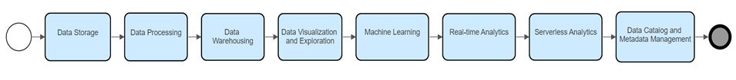

* **Data Storage**: Use Amazon S3 (Simple Storage Service) to store your data securely and durably in the cloud.
* **Data Processing**: Utilize Amazon EMR (Elastic MapReduce) or AWS Glue for distributed data processing and transformation. EMR supports popular frameworks like Apache Hadoop and Spark, while AWS Glue offers serverless data integration and ETL (Extract, Transform, Load) capabilities.
* **Data Warehousing**: Leverage Amazon Redshift, a fully managed data warehouse service, to store and analyze large volumes of structured data efficiently. Redshift provides high performance and scalability for complex analytical queries.
* **Data Visualization and Exploration**: AWS QuickSight enables you to create interactive dashboards and visualizations from your data. It integrates with various AWS data sources and supports a wide range of visualization options.
* **Machine Learning**: AWS provides a suite of AI and ML services, such as Amazon SageMaker, which enables you to build, train, and deploy machine learning models for predictive analytics and data-driven insights.
* **Real-time Analytics**: AWS offers Amazon Kinesis, a platform for real-time streaming data analytics. With Kinesis, you can process and analyze streaming data from various sources, such as IoT devices or application logs.
* **Serverless Analytics**: AWS Athena allows you to query data directly from Amazon S3 using standard SQL queries without the need for managing infrastructure. It provides a serverless and cost-effective way to analyze large datasets stored in S3.
* **Data Catalog and Metadata Management**: AWS Glue provides a fully managed metadata catalog that helps discover, organize, and manage metadata for your data assets across various data sources.

**AWS Analytics Services Provides:**

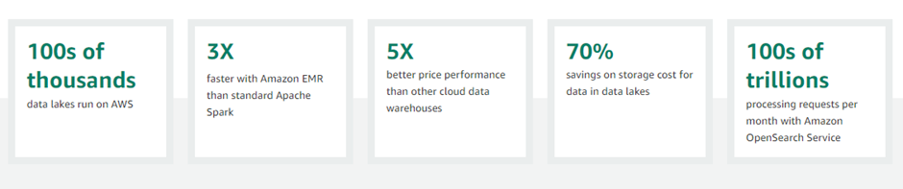

Ø **Advantages of using AWS in Data Analytics**

* **Scalability:** AWS offers a highly scalable infrastructure that can handle large volumes of data and accommodate fluctuating workloads. You can easily scale up or down your resources based on demand, ensuring optimal performance and cost efficiency.
* **Broad Range of Services**: AWS provides a comprehensive suite of services specifically designed for data analytics, including data storage, processing, warehousing, visualization, and machine learning. This eliminates the need to manage and integrate multiple tools from different vendors, streamlining the analytics workflow.
* **Cost Effectiveness**: AWS offers a pay-as-you-go pricing model, allowing you to only pay for the resources and services you actually use. This eliminates the need for large upfront investments and provides cost flexibility.
* **Security and Compliance**: AWS maintains a robust and secure infrastructure that adheres to industry best practices and compliance standards. With features like encryption, access control, monitoring, and auditing capabilities, AWS helps protect your data and ensures regulatory compliance.
* **Flexibility and Agility**: AWS provides a wide range of services and configurations, allowing you to choose the most suitable tools and technologies for your specific data analytics needs. This flexibility enables you to experiment, innovate, and adapt to changing requirements quickly and easily.
* **Integration with Other AWS Services**: AWS services are tightly integrated with each other, enabling seamless data movement and integration across different components of your analytics pipeline. This integration simplifies data workflows, improves data governance, and facilitates the development of end-to-end analytics solutions.
* **Global Infrastructure:** AWS has a global presence with data centers located in different regions worldwide. This allows you to store and process data closer to your users or comply with data sovereignty requirements.
* **Reliability and High Availability**: AWS infrastructure is designed for high availability and fault tolerance. It offers features such as automated backups, data replication, and load balancing, ensuring that your data analytics applications are highly reliable and resilient.

**2. What AWS services are used in blockchain implementation?**

* 25% of all Ethereum workloads in the world run on AWS.
* Enterprise customers for Hyperledger Fabric include Nestle, Sony Music, BMW, Sage, Guardian, DTCC, Workday, Klarna Bank, SGX, Legal & General, Splunk, Zilliant, Contura Energy, DVLA UK, and many more.

**AWS Blockchain Services Provides:**

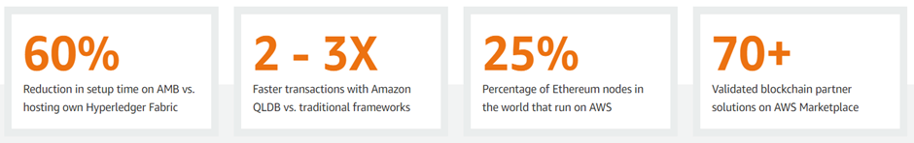

Ø **AWS Blockchain services**

* Amazon Quantum Ledger Database (QLDB)
* Amazon Managed Blockchain
* AWS Blockchain Partners

Ø **Amazon Quantum Ledger Database (QLDB):**

Amazon QLDB (Quantum Ledger Database) is a fully managed ledger database service provided by AWS that offers a centralized, immutable, and cryptographically verifiable transaction log. It is designed to provide transparent and tamper-proof storage for applications that require an authoritative and auditable record of all changes to their data.

**Functionality of QLDB:**

* **Immutable Transactions**: Once a transaction is committed to QLDB, it becomes an immutable part of the transaction history and cannot be altered or deleted.
* **Cryptographically Verifiable:** QLDB uses cryptographic hashing to create a unique hash for each transaction.
* **Centralized Ledger:** QLDB provides a single, centralized ledger that maintains a complete and transparent history of all transactions.
* **Scalability and Performance**: QLDB is designed to scale horizontally and handle high read and write throughput.
* **SQL-like Query Language:** QLDB supports a familiar SQL-like query language called PartiQL, which allows you to query and retrieve data from the ledger using standard SQL syntax.
* **Serverless Architecture:** QLDB is a serverless service, which means that you don't need to provision or manage any underlying infrastructure.
* **Integration with AWS Services:** QLDB can be integrated with other AWS services, such as AWS Lambda, Amazon S3, or AWS CloudTrail, to build end-to-end applications and leverage additional functionality.

Ø **Amazon Managed Blockchain:**

Amazon Managed Blockchain is a fully managed service provided by AWS that makes it easy to create and manage scalable blockchain networks using popular frameworks like Ethereum and Hyperledger Fabric.

**Functionality of Amazon Managed Blockchain:**

* **Network Creation and Management**: Amazon Managed Blockchain allows you to create and configure blockchain networks with just a few clicks. You can choose between Ethereum or Hyperledger Fabric frameworks, select the desired consensus algorithm, and define the network's configuration parameters.
* **Scalability and High Availability**: Managed Blockchain automatically scales the infrastructure to accommodate the needs of your network, ensuring high availability and performance.
* **Secure Network Access and Identity Management**: Managed Blockchain integrates with AWS Identity and Access Management (IAM) to manage network access and permissions.
* **Node Deployment and Management**: The service simplifies the deployment and management of blockchain nodes. It handles tasks such as node provisioning, peer configuration, and maintaining the network's shared ledger.
* **Monitoring and Logging**: Managed Blockchain integrates with Amazon CloudWatch for monitoring and logging. You can track network performance, view logs, and set up alerts to ensure the health and security of your blockchain network.
* **Integration with AWS Services**: Managed Blockchain seamlessly integrates with other AWS services. For example, you can store off-chain data in Amazon S3, trigger serverless functions with AWS Lambda, or integrate with databases like Amazon Aurora.
* **Secure and Reliable Infrastructure**: Managed Blockchain leverages AWS's robust infrastructure, which provides high security, durability, and availability. Data is encrypted at rest and in transit, and the service integrates with AWS Key Management Service (KMS) for secure key management.

Ø **AWS Blockchain Partners:**

AWS has a robust partner ecosystem that includes various blockchain partners. These partners offer specialized services, solutions, and expertise in implementing blockchain solutions on AWS.

Here are a few examples of AWS Blockchain Partners:

* ConsenSys
* R3
* IBM
* Chainyard
* Infosys
* Kaleido
* Splunk

**3. Describe the AWS services and tools that are commonly used for data analytics.**

* **Amazon S3 (Simple Storage Service):** Amazon S3 is a scalable object storage service that provides durable and cost-effective storage for large volumes of data. It is commonly used as a data lake to store raw and processed data for analytics.
* **Amazon Redshift:** Amazon Redshift is a fully managed data warehousing service that provides high-performance and scalable data storage and analysis. It is optimized for online analytical processing (OLAP) and is suitable for running complex queries on large datasets.
* **Amazon Athena:** Amazon Athena is an interactive query service that allows you to analyze data stored in Amazon S3 using standard SQL queries. It enables ad hoc analysis and exploration of data without the need for infrastructure setup or data loading.
* **Amazon EMR (Elastic MapReduce):** Amazon EMR is a big data processing service that provides a managed Hadoop framework, along with other popular frameworks like Apache Spark and Presto. EMR allows you to process and analyze large datasets using distributed computing.
* **AWS Glue:** AWS Glue is a fully managed extract, transform, and load (ETL) service that makes it easy to prepare and transform data for analytics. It offers automated schema discovery, data cataloging, and data transformation capabilities.
* **Amazon QuickSight:** Amazon QuickSight is a cloud-native business intelligence (BI) service that allows you to create interactive visualizations, reports, and dashboards from your data. It provides easy-to-use tools for data exploration and presentation.
* **AWS Lake Formation:** AWS Lake Formation is a service that simplifies the process of building and managing data lakes on AWS. It provides automated data ingestion, data transformation, and data security controls for setting up and managing data lakes.
* **AWS Glue DataBrew:** AWS Glue DataBrew is a visual data preparation tool that helps clean and normalize data for analysis. It offers a no-code interface for data wrangling tasks like data cleansing, normalization, and structuring.
* **Amazon Kinesis:** Amazon Kinesis is a platform for real-time streaming data ingestion and processing. It allows you to collect, process, and analyze streaming data from various sources for real-time analytics and insights.
* **Amazon Forecast:** Amazon Forecast is a fully managed service that uses machine learning to generate accurate forecasts based on historical data. It is commonly used for demand forecasting, inventory planning, and resource optimization.

AWS Analytics Services Used Commonly are:

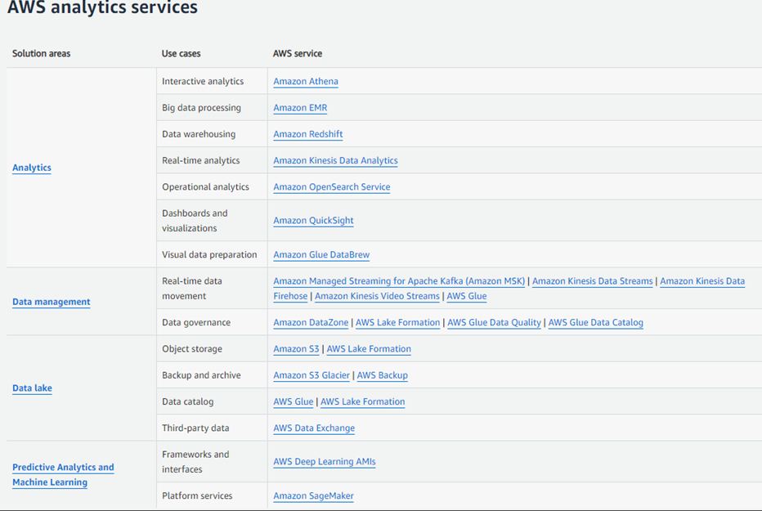

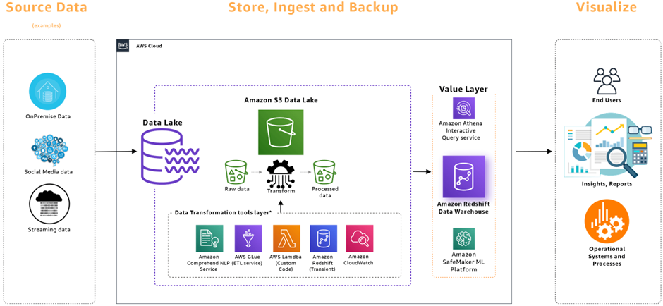

What are the different data storage options provided by AWS for data analytics

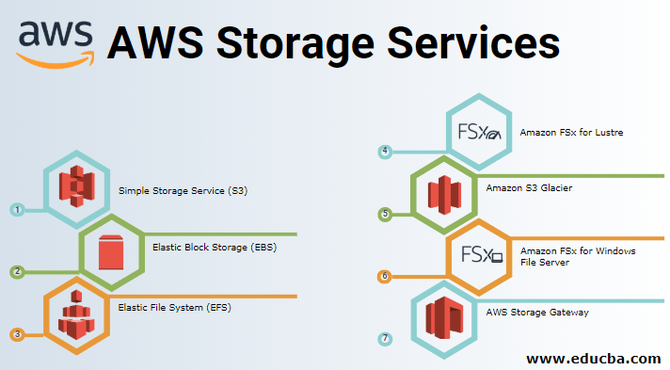

* **Amazon S3 (Simple Storage Service):** With its high durability, scalability, and security, S3 is an excellent option for storing large volumes of data used in analytics. It allows you to store structured, semi-structured, and unstructured data, and you can directly query this data using AWS analytics services or third-party tools.
* **Amazon Redshift:** Redshift is a fully managed data warehousing service optimized for analytics workloads.

It enables you to efficiently analyze large datasets by leveraging columnar storage, parallel query execution, and integration with popular analytics and ETL tools. Redshift is particularly suitable for complex analytics queries and generating insights from vast amounts of data.

* **Amazon Athena:** Athena is an interactive query service that enables you to analyze data directly from S3 using standard SQL queries. It eliminates the need for upfront data transformation or loading into a separate database.

With Athena, you can perform ad hoc querying and exploration of data in S3, making it ideal for quick data discovery and analysis.

* **Amazon ElasticSearch Service**: ElasticSearch is a managed service that simplifies the deployment and scaling of the Elasticsearch open-source search and analytics engine.

It provides powerful search, analysis, and visualization capabilities for real-time data. ElasticSearch is commonly used for log analytics, full-text search, and real-time application monitoring, supporting use cases such as anomaly detection and log analysis.

* **Amazon EMR (Elastic MapReduce):** EMR is a managed big data platform that facilitates processing and analysis of large datasets using popular frameworks like Apache Spark, Hadoop, and Presto. It allows you to store data in various AWS storage options, including S3 and HDFS. EMR provides a scalable and cost-effective solution for running distributed analytics workloads, enabling you to perform complex data transformations and advanced analytics.
* **Amazon DynamoDB**: DynamoDB is a fully managed NoSQL database that offers fast and predictable performance for applications requiring low-latency data access. While primarily used as a transactional database, DynamoDB can also be leveraged for basic data analytics tasks. It supports filtering, aggregations, and global secondary indexes, allowing you to perform simple analytics operations on your data.
* **Amazon FSx for Lustre:**Luster is a file system used for compute-intensive workloads. This mainly comes into the picture when you run machine learning operations on large data sets or when you need to run media encoding workloads. Running Lustre separately requires a lot of expertise in setting it up and configuring it for the right workloads. With the help of Amazon FSx, this can be avoided and a simple interface on the console helps you to quickly get started and start working on your data. The ability to connect it seamlessly to S3 and the option of running it in VPC provides a low cost yet a performant way to achieve your compute-intensive workloads leveraging luster without the administrative overhead of running it.

Explain the concept of server less computing in AWS and its relevance to data analytics.

## What is serverless computing in AWS?

Serverless computing allows you to build and run applications and services without thinking about servers. With serverless computing, your application still runs on servers, but all the server management is done by AWS.

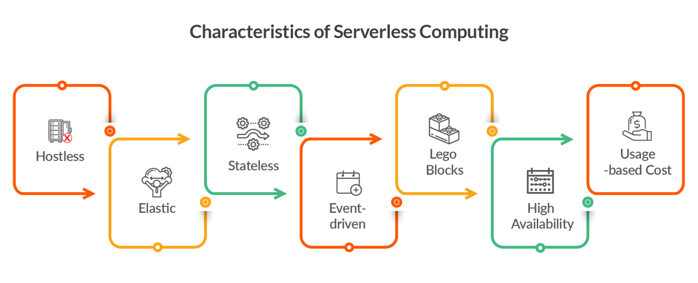

Serverless computing, in the context of AWS, refers to a cloud computing model where developers can build and run applications without the need to provision or manage servers. AWS takes care of infrastructure management, allowing developers to focus solely on writing code. AWS Lambda is the primary service offered by AWS for serverless computing.

In serverless computing, applications are broken down into smaller, event-driven functions that are executed in response to specific events or triggers. Each function performs a specific task and can be invoked independently. When an event occurs, such as an API request or changes to a database, the corresponding function is automatically executed, scales dynamically, and runs in an isolated environment.

## **Relevance to data analytics.**

**Cost efficiency:** Serverless computing in AWS charges only for actual function execution time, making it cost-effective for sporadic or unpredictable data analytics workloads, without charges for idle time or server provisioning.

**Scalability:** AWS Lambda automatically scales functions based on workload, allowing data analytics applications to handle varying data volumes and spikes in demand, ensuring efficient resource allocation for processing large datasets or concurrent tasks.

**Real-time analytics:** Serverless computing in AWS, like AWS Lambda, is ideal for real-time analytics, as serverless functions can be triggered to process and analyze data events instantly, enabling organizations to gain real-time insights and make timely decisions based on up-to-date information.

**Data processing and transformation:** Serverless computing, like AWS Lambda, is ideal for data processing and transformation in analytics workflows. Lambda functions can perform ETL tasks, extracting, transforming, and loading data from various sources, enabling data preprocessing and preparation before storage in a data warehouse or analytics platform.

**Integration with other AWS services:** AWS Lambda seamlessly integrates with AWS services such as S3, DynamoDB, Redshift, and Athena. This integration allows for building end-to-end data pipelines, where Lambda functions interact with other services to perform comprehensive data analytics tasks. By combining different AWS services, you can create robust data analytics solutions, from data ingestion and storage to processing and analysis.

Describe the security and compliance measures provided by AWS for data analytics workloads.

**Encryption at Rest and in Transit:** AWS enables encryption mechanisms to protect data at rest and in transit for data analytics workloads. You can encrypt data stored in Amazon S3, Amazon Redshift, or other data storage services using AWS Key Management Service (KMS). Additionally, you can enable SSL/TLS encryption for data transmitted between AWS services or between AWS and your applications, ensuring the security of data during transit.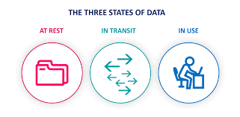



**Fine-Grained Access Control:** AWS Identity and Access Management (IAM) allows you to define and manage granular access policies for data analytics resources. You can assign specific permissions to users or roles, controlling their access to data, services, and resources. This ensures that only authorized individuals can access and manipulate data within your data analytics workflows.



**Compliance and Certifications:** AWS maintains industry-leading compliance certifications (SOC 1, SOC 2, ISO 27001, HIPAA, GDPR), demonstrating adherence to rigorous security standards and enabling compliance with industry-specific regulations for data protection.



**Auditing and Monitoring:** AWS CloudTrail captures API activity logs, while CloudWatch enables monitoring of data analytics performance and operational metrics, ensuring comprehensive auditing and real-time monitoring for enhanced security.



**Secure Networking:** AWS provides Virtual Private Cloud (VPC), which allows you to create isolated virtual networks for your data analytics workloads. You can define network access control policies, configure subnets, and set up security groups to control inbound and outbound traffic. This helps secure your data analytics environment and isolate it from external threats.



**Data Lifecycle Management**: AWS services like S3 Lifecycle Management automate data movement between storage tiers and enable data retention and disposal based on predefined rules, ensuring compliant data lifecycle management and minimizing storage costs.

* **What are some best practices for optimizing cost and performance in AWS data analytics deployments?**

**Kinesis Data Streams**

* The fundamental unit of scaling for Kinesis Data Streams is a shard. A Kinesis data stream consists of several shards, and each shard provides a specific data ingestion and delivery rate (1 MB/s write and 2 MB/s reads). Each Kinesis data stream (on-demand mode) gets a default capacity of 4 MB/s (4000 records/s) for writes and can burst up to 200 MB/s (200K records/s).
* On-demand mode is suitable for unpredictable traffic. In on-demand mode, Kinesis automatically manages the number of shards needed to provide the required throughput. For example, a data stream in on-demand mode observes peak write throughput for the last 30 days and automatically provisions capacity for double that rate. If a new peak is observed, capacity is adjusted to reflect that peak. As a result, aggregate read throughput for the whole stream increases proportionally to write throughput. Please note that if the traffic increases more than double the previous peak within 15 minutes, write throttling can occur. Requests that are throttled require a retry mechanism.
* Provisioned mode is suitable for predictable traffic volumes that are easy to forecast. In provisioned capacity mode, customers must provide an appropriate number of shards needed for the application.

### **Kinesis Data Firehose**

* Kinesis Firehose and Data Analytics are serverless and fully managed services, so you don't have to worry about scaling. However, you must pay attention to the quotas(limits) for [Firehose](https://docs.aws.amazon.com/firehose/latest/dev/limits.html) and [Data Analytics](https://docs.aws.amazon.com/kinesisanalytics/latest/dev/limits.html). Please also note that increasing the Firehose quota significantly more than your actual utilization can increase costs for the destination services. For example, Firehose will deliver data in smaller batches to the destination, which would impact API costs to your downstream destination, such as S3.
* For Apache Flink applications, you can use the application autoscaling. For autoscaling based on custom metrics, you can use the [custom autoscaling policy](http://aws.amazon.com/blogs/big-data/enhanced-monitoring-and-automatic-scaling-for-apache-flink/) of Amazon CloudWatch.

**Amazon Managed Streaming for Apache Kafka (Amazon MSK)**

* Amazon MSK provisioned has two options to expand cluster storage in response to increased usage – automatic and manual scaling. Increased usage may occur due to increased throughput from producers and data retention requirements. The size or family of brokers is adjusted to the MSK cluster's compute capacity based on changes in workloads without interrupting cluster I/O. Amazon MSK Serverless is an option for applications with intermittent or unpredictable workloads. Vertical scaling can be increased or decreased, but this will not work if the number of partitions per broker exceeds the maximum number specified for the new instance size.
* Automatic Scaling: Amazon MSK can automatically scale using an auto-scaling policy where the target disk utilization and maximum scaling capacity are set. It is important to note that a storage scaling action can occur only once every six hours. Verify if the region you are using MSK supports automatic scaling in the Automatic Scaling documentation. Manual scaling can be used if the chosen region is not listed.
* Manual Scaling: Amazon MSK can scale up broker storage via the Console or CLI. It is important to note that storage scaling has a cool-down period of at least six hours between events. Even though the operation makes additional storage available immediately, the service performs optimizations on your cluster that can take up to 24 hours or more. The duration of these optimizations is proportional to your storage size.
* MSK Serverless: The Serverless is an option for Amazon MSK's cluster type, where it automatically provisions and scales capacity without thinking about right-sizing or scaling. Consider using a serverless cluster if your applications need the on-demand streaming capacity that scales up and down automatically. However, serverless performance is directly affected by the number of partitions, so partitions must be created accordingly to match the number of producers and consumers.

**Amazon Simple Storage Service**

**Storage Classes**

**S3 storage classes** – S3 offers a range of storage classes designed for different use cases. Choosing a suitable storage class can help you be more performant and save a lot of costs. Considerations when choosing a storage class

**Predictable access patterns** - Datasets such as medical records, media streaming, learning resources, and user-generated content such as photographs are frequently accessed during a specific time and then rarely accessed. For use cases like these, you can plan (lifecycle policies) to move to a lower-cost storage class optimized for infrequent or archive access once the usage of these objects reduce. For predictable workloads, leverage S3 Storage Class Analysis to monitor access patterns across objects and decide when to transition data to the proper storage class to optimize costs.

**Unpredictable access patterns** - Datasets such as long tail data, data lakes, and data analytics have unpredictable usage patterns. The access patterns for these use cases are highly variable over the year. They can range from little to no access to data being read multiple times in a month or even a single day, leading to high retrieval charges if stored in infrequent access or archive storage class. Use S3 intelligent tiering for such workloads.

**Cheaper storage class does not guarantee lower S3 costs** - Along with the storage fee, there is a fee for data retrieval, minimum duration, and API calls for a few storage classes. For example, **S3 Glacier Instant Retrieval** is the ideal storage class if you access data once per quarter. However, although the storage price is lower than S3 Standard-IA, there is an added cost to access the data. Therefore, there is a break-even point where if you’re storing data that is accessed too frequently, it makes sense to keep that in S3 Standard-IA (cheaper storage and no retrieval fee). In addition, S3 Glacier Instant Retrieval has a minimum storage duration of 90 days. So, if you upload a file you expect to delete within 90 days, you will be charged a prorated early deletion fee. We recommend you choose the S3 Standard or the S3 Standard-IA storage classes in such cases.

You should upload directly to **S3 Glacier** if you know the data is accessed not more than once a quarter.

**Amazon S3 Storage lens**

Amazon S3 storage lens is an analytics solution that provides visibility into object storage with point-in-time metrics, trend lines, and actionable recommendations. The Amazon S3 Storage lens will help you discover anomalies and identify cost efficiencies

**File formats**

Choose appropriate file formats. The file type, compression strategy, and partitioning you use on S3 will significantly impact performance and cost. Storing data in its raw format takes up a lot of space, is inefficient, and is expensive. Instead, use file formats such as parquet, Avro, and orc to speed up read/writes and compress data, using less storage space. Parquet and ORC are suitable for columnar storage and frequent reads over writes; they also compress better than Avro. On the other hand, Avro is suitable for row-based storage and is faster for frequent writes than reads.

**Batch operations**

S3 Batch operations is a managed service that lets you manage billions of objects at scale. You can change object metadata and properties, copy or replicate objects between buckets, replacing object tag sets, modify access controls and restore archived objects from the S3 glacier. You need not write code, set up servers (compute charges) or figure out how to partition the loads between servers, worry about S3 throttling and pay no compute charge because AWS will handle all these tasks for you.

**Workload management (WLM) and concurrency scaling**

When you have multiple sessions or users running queries simultaneously, some queries may take longer to run or consume more resources than others and affect the performance of other queries. Workload Management can define multiple query queues and route queries to the appropriate queues at runtime to help handle these situations.

There are options for Automatic WLM and Manual WLM. Automatic WLM will automatically manage how many queries run concurrently and how much memory is allocated to each dispatched query. In addition, you can specify the priority of workloads or users that map to each queue. With Manual WLM, you configure the specific queues used to manage queries. You can also set up rules to route queries to particular queues based on the user running the query or specified labels.

Concurrency scaling is cost-effective for spiky workloads where you require additional capacity for short periods instead of provisioning additional persistent nodes in your cluster. To implement concurrency scaling, you can route queries to Concurrency scaling clusters with a workload manager.

* **Explain the concept of data governance in the context of AWS data analytics.**

When you hear the term “data governance,” you might associate it with highly-regulated industries such as healthcare and financial services. But smart businesses across all industries recognize using data effectively can provide a competitive advantage. A 2021 report on confident decision making with data indicated that “66% of data and analytics professionals experienced improved data quality as a ‘leading benefit’ when implementing data governance programs, a trend that rose to a staggering 83% for organizations that already have a mature data governance framework in place.”

Your small or medium business (SMB) might have moved some of its data workflows to the cloud to improve remote collaboration or security during work-from-home orders. What you may not recognize is that you took the first step towards establishing a data-centric approach to your business. In the cloud, your organization’s data must be reliable and trusted, through well-established patterns and processes. This helps you and your team develop accurate insight into your business initiatives.

**What is data governance?**

Let’s take a deep dive into this topic by defining it. Data governance is the process to ensure the integrity, availability, usability, and security of an organization’s data. Given its importance to your business, how you govern it matters significantly. Some common governance categories include:

* Transaction data
* Reference data
* Customer data
* Product data

Data governance includes developing policies, procedures, use of technology, operationalizing processes, and putting in place a culture of data ownership. This means setting up internal standards that apply to how data is ingested, processed, accessed, and eventually disposed of. It also ensures compliance with external standards set by government agencies, industry associations, and other relevant third parties.

Most SMBs may not have the resources or time to manage and maintain large amounts of customer data. But the true costs of poor data management aren’t just in money—lost and damaged data can lead to poor customer trust. Data governance is about establishing policies to ensure your organization adheres to best practices for managing and protecting its proprietary data.

The risks of not having a data governance strategy

* SMBs should strongly consider data governance, whether they’re a team of 10 or 100. Implementing an effective strategy helps in mitigating these five common challenges:
* Erosion of customer trust and credibility: Unreliable or inaccurate data damages a company’s reputation and in some cases, it may be irreparable (especially in a competitive industry).

Increase in data management cost: Storage costs for duplicate or redundant data and compliance fines are also contributors to data management costs.

* Misuse of data: Without a form of governance, different or incorrect conclusions can easily be made from the same dataset.

Regulatory and compliance violations: For SMBs, fines levied by regulatory bodies might not be as easily absorbed compared to venture-backed startups and large enterprises.

Higher likelihood of security events: Ungoverned data could lead to outside parties or unauthorized users accessing the information.

|  |  |
| --- | --- |
|  |  |

* **How can AWS data analytics services be used in specific industries, such as retail, healthcare, or finance?**

**AWS for Health**

Healthcare and life science organizations are reinventing how they collaborate, make data-driven clinical and operational decisions, enable precision medicine, and decrease the cost of care. To help healthcare and life science organizations achieve business and technical goals, AWS for Health provides an offering of AWS services and AWS Partner solutions, used by thousands of customers globally.

|  |  |
| --- | --- |
|  | To deliver patient-centered care, organizations in the heavily-regulated healthcare industry—from providers and payors to healthtech—need to increase the pace of innovation and unlock the potential of data, all while keeping health information secure and private. AWS empowers health organizations to improve patient outcomes and accelerate the digitization and utilization of their data with the broadest and deepest portfolio of cloud services and purpose-built partner solutions.      **AWS for Financial Services**  AWS is a pioneer at the intersection of financial services and technology, enabling our customers to optimize operations and accelerate innovation through the broadest set of services and partner solutions—all while adapting to ever-changing regulations. Thousands of financial services firms, from the fastest-growing fintechs to systemically important financial institutions, are redefining their future on AWS.      **10. AWS Personalize enable personalized recommendations and customer segmentation in data analytics**  AWS Personalize facilitates the implementation of personalized recommendations and customer segmentation within data analytics applications through its sophisticated machine learning capabilities. By leveraging advanced algorithms and techniques, AWS Personalize empowers businesses to unlock valuable insights from vast amounts of customer data.  The essence of AWS Personalize lies in its ability to process and analyze extensive datasets, employing cutting-edge algorithms such as collaborative filtering, deep learning, and reinforcement learning. These algorithms enable the system to discern intricate patterns and correlations within the data, ultimately leading to accurate predictions and recommendations tailored to individual preferences.  To achieve personalized recommendations, AWS Personalize leverages historical customer interactions, such as purchases, clicks, and ratings. By assimilating this rich information, the system becomes adept at understanding user behavior and anticipating their preferences. Consequently, it can offer personalized recommendations that resonate with each user's unique tastes and preferences.  Furthermore, AWS Personalize facilitates customer segmentation, a crucial aspect of data analytics applications. By employing a variety of characteristics, behaviors, or preferences, the system can categorize customers into distinct segments. This segmentation allows businesses to create targeted marketing campaigns, craft personalized messaging, and curate bespoke user experiences. By tailoring their approach to specific customer segments, businesses can enhance customer engagement, satisfaction, and ultimately drive revenue growth.  In essence, AWS Personalize empowers businesses to unlock the full potential of their customer data by employing advanced machine learning techniques. By delivering personalized recommendations and enabling customer segmentation, AWS Personalize enhances the effectiveness of data analytics applications, fostering a deeper understanding of customers and driving impactful decision-making.  **11. The role of AWS IoT Analytics in processing and analyzing data from IoT devices**  AWS IoT Analytics plays a pivotal role in processing and analyzing data generated by Internet of Things (IoT) devices, transforming it into actionable insights that can drive informed decision-making. With its robust capabilities, AWS IoT Analytics enables businesses to efficiently handle and extract value from the vast volumes of data generated by IoT devices.  At its core, AWS IoT Analytics serves as a comprehensive solution for data ingestion, processing, storage, and analysis. It offers a scalable infrastructure that can accommodate the immense scale and velocity of IoT data streams, ensuring the reliable and secure transmission of data from devices to the analytics platform.  Once the IoT data is ingested, AWS IoT Analytics provides powerful tools and mechanisms for processing and transforming the data into a usable format. It supports data cleansing, normalization, and enrichment operations, allowing businesses to ensure the quality and consistency of the IoT data. This data preparation stage is crucial for generating reliable and accurate insights.  After data preparation, AWS IoT Analytics offers a suite of analytical capabilities, including advanced algorithms, statistical analysis, and visualization tools. These tools enable businesses to extract meaningful patterns, correlations, and anomalies from the IoT data. By applying sophisticated machine learning techniques, AWS IoT Analytics can uncover hidden insights and predictive models that empower businesses to make informed decisions and take proactive actions.  The insights derived from AWS IoT Analytics can be utilized across various industries and use cases. For instance, in manufacturing, it can help optimize production processes and predict equipment failures. In healthcare, it can enable remote patient monitoring and early detection of health issues. In smart cities, it can assist in traffic management and resource optimization. The possibilities are vast.  In summary, AWS IoT Analytics serves as a critical component in the IoT ecosystem, enabling businesses to harness the potential of IoT data. By efficiently processing and analyzing data from IoT devices, AWS IoT Analytics empowers businesses to derive actionable insights, unlocking opportunities for improved operational efficiency, enhanced customer experiences, and strategic decision-making.  **12. Concept of data anonymization and the tools provided by AWS**  The concept of data anonymization is rooted in the pursuit of privacy-preserving analytics, aiming to safeguard sensitive information while still allowing analysis and insights to be derived from datasets. Data anonymization involves the process of removing or obfuscating personally identifiable details, ensuring that data cannot be linked back to specific individuals, thereby protecting their privacy.  AWS offers a range of tools to facilitate data anonymization and support privacy-preserving analytics practices. One such tool is Amazon Macie, an AI-powered service that automatically detects, classifies, and safeguards sensitive data stored within the AWS infrastructure. Leveraging machine learning algorithms, Amazon Macie identifies and categorizes sensitive information, enabling businesses to implement appropriate anonymization techniques to protect the privacy of individuals.  Additionally, AWS provides Amazon Athena, a serverless query service that allows users to analyze data in Amazon S3. With Athena, businesses can perform anonymization during query execution by leveraging its advanced capabilities for complex transformations and anonymization functions. This empowers users to replace or mask personally identifiable information (PII) in real-time queries, ensuring that sensitive data remains anonymous and compliant with privacy regulations.  Another valuable tool for privacy-preserving analytics is AWS Glue, a fully managed extract, transform, and load (ETL) service. AWS Glue facilitates data transformations and anonymization as part of the data preparation process. By utilizing AWS Glue, businesses can cleanse and anonymize datasets before analysis, ensuring adherence to privacy regulations and protecting the confidentiality of individuals' data.  These AWS tools contribute to the practice of privacy-preserving analytics by providing businesses with the means to comply with privacy regulations such as GDPR (General Data Protection Regulation) or CCPA (California Consumer Privacy Act). By anonymizing data, organizations can mitigate the risk of data breaches and unauthorized access to sensitive information, fostering trust and ensuring the privacy rights of individuals are upheld.  In conclusion, data anonymization is a critical aspect of privacy-preserving analytics, and AWS offers robust tools such as Amazon Macie, Amazon Athena, and AWS Glue to support businesses in anonymizing data and protecting individual privacy. By leveraging these tools, organizations can comply with privacy regulations and confidently perform analytics while upholding the privacy rights of their customers or users.  **13. Integration of AWS Lambda and AWS Batch in serverless data processing**  The integration of AWS Lambda and AWS Batch in serverless data processing and analytics workflows brings together powerful capabilities to enable efficient and scalable processing of data.  AWS Lambda, a serverless compute service, plays a key role in executing code in response to events without the need for managing servers. It operates on a "pay-per-use" model, where businesses are billed only for the compute time consumed during code execution. This serverless approach provides automatic scalability, eliminating the need for manual infrastructure provisioning.  When integrated with AWS Batch, a fully managed batch processing service, AWS Lambda enhances the processing capabilities of data workflows. AWS Batch enables businesses to execute batch computing jobs efficiently, handling the orchestration of resources and ensuring high-performance execution of jobs at scale. By combining AWS Lambda and AWS Batch, businesses can achieve flexible and optimized data processing workflows.  In this integration, AWS Lambda functions can be utilized within the data processing workflow to perform specific tasks. For example, AWS Lambda can be employed for data ingestion, where it can process incoming data streams and trigger subsequent processing steps. It can also be used for data transformation, enrichment, or filtering tasks, allowing businesses to apply custom logic and operations to the data.  AWS Batch, on the other hand, manages the overall workflow execution by orchestrating and distributing batch computing jobs across available resources. It ensures efficient resource utilization, automatically scaling resources up or down based on the workload demands. AWS Batch enables businesses to process large volumes of data in parallel, optimizing performance and reducing processing time.  By integrating AWS Lambda and AWS Batch, businesses can create serverless data processing and analytics workflows that are highly scalable, cost-effective, and resilient. The combination of Lambda's event-driven and on-demand compute capabilities with Batch's robust job management and resource orchestration capabilities allows businesses to handle data processing tasks efficiently and seamlessly. This integration empowers organizations to focus on data analysis and deriving actionable insights, without the need to manage complex infrastructure or worry about provisioning resources.  In summary, the integration of AWS Lambda and AWS Batch in serverless data processing and analytics workflows provides businesses with a powerful framework to process and analyze data efficiently. By leveraging the event-driven nature of Lambda and the batch processing capabilities of AWS Batch, organizations can build scalable, cost-effective, and flexible data workflows, enabling them to extract valuable insights from their data with ease. |